**Basics of Python**

**Author:** Apurva Sachin Kulkarni

**Date:** 13th August, 2025

**Introduction**

This document provides a comprehensive overview of essential Python programming concepts and best practices. It explains how modern techniques such as list and dictionary comprehensions help write concise and efficient code, how file handling enables real-world data storage and retrieval, and how error handling makes programs robust and user-friendly. Additionally, it highlights the importance of coding standards to ensure code quality, maintainability, and team collaboration. Together, these topics form a solid foundation for writing clean, reliable, and production-ready Python applications.

**1. List Comprehension**

Python provides multiple ways to create and manipulate lists, but list comprehension stands out as a concise, readable, and efficient method. Instead of writing multi-line loops to build lists, list comprehensions express the same logic in a single line, improving code quality and maintainability. They combine iteration, transformation, and optional filtering into a compact syntax, making them a preferred approach among Python developers.

List comprehensions are a powerful feature in Python that enable developers to build and transform lists with minimal code. They enhance code readability, performance, and maintainability while reducing redundancy. For Python programmers, mastering list comprehensions is an essential step toward writing elegant, efficient, and "Pythonic" code.

**Why is List Comprehension Needed?**

1. **Conciseness:** Traditional loops for list creation can require multiple lines of code. List comprehensions reduce this to a single, elegant expression.
2. **Improved Readability:** The syntax closely reflects the developer’s intent, making the code easier to understand at a glance.
3. **Performance Benefits:** List comprehensions are implemented in C (internally within Python), making them slightly faster than manually appending elements inside a loop.
4. **Reduced Boilerplate:** Eliminates the need for explicitly declaring an empty list and appending elements iteratively.
5. **Versatility:** Supports both simple transformations (e.g., squaring numbers) and complex operations such as nested iterations or conditional filtering.

**General Syntax:**



**Components:**

* **expression:** Operation or transformation applied to each item.
* **item:** Variable representing each element from the iterable during iteration.
* **iterable:** Any sequence (list, tuple, string, range, etc.) to iterate over.
* **condition** (optional)**:** Filter to include only certain elements in the output list.

**Advantages of List Comprehension:**

* **Concise syntax:** Reduces lengthy code into one-liners.
* **Readable and expressive:** The intent of the operation is clear.
* **Faster execution:** Often runs faster than traditional loops.
* **Flexibility:** Handles transformations, filtering, and even nested loops.
* **Pythonic style:** Aligns with Python's emphasis on clean, expressive code.

**Example – Squares of Even Numbers**

**Without using list comprehension:**

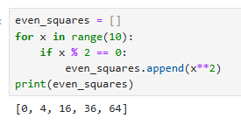

**Using list comprehension:**

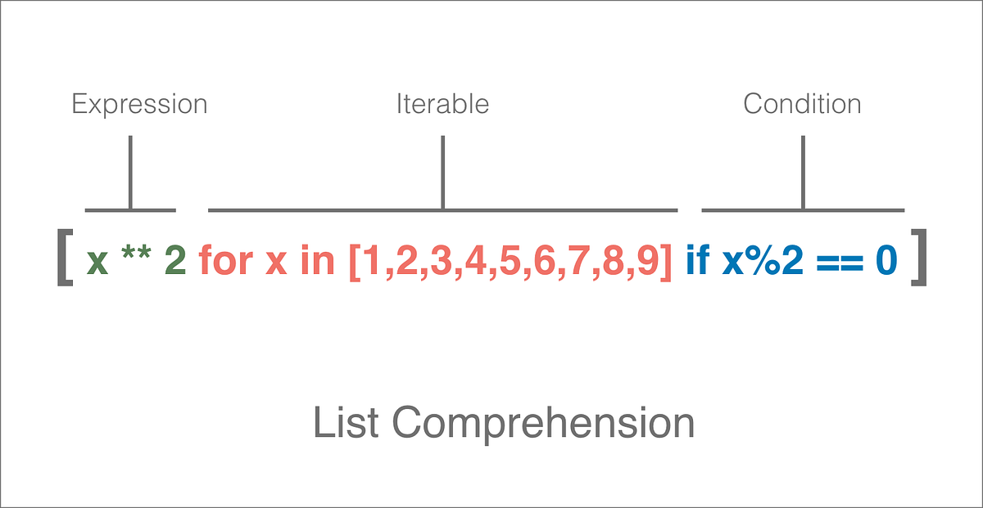

**Fig. 1: Example Showing List Comprehension**

**How It Works:**

1. **Iterable:**  
   The list [1, 2, 3, 4, 5, 6, 7, 8, 9] is the sequence we are looping over.
2. **Condition:**  
   if x % 2 == 0 selects only even numbers from the iterable.
3. **Expression:**  
   x**2 squares each selected number and adds it to the new list.

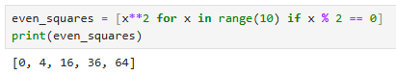

**Key Distinctions Between List Comprehension and Traditional Loop:**

**Table 1: List Comprehension vs Traditional Loop**

|  |  |  |
| --- | --- | --- |
| **Aspect** | **Using List Comprehension** | **Without Using List Comprehension** |
| **Code Length and Readability** | One concise line directly showing the intent | Requires more lines with explicit append and conditional block. |
| **Clarity of Intent** | Expression is compact and reads almost like English. | More verbose, but may be clearer for beginners learning step-by-step flow. |
| **Performance** | Slightly faster because it’s optimized internally. | A bit slower due to repeated method calls (append) inside the loop. |
| **Use Cases** | Best when the transformation is simple and clear in one line. | Better if the logic is complex, involves multiple operations, or requires debugging at each step. |

**Examples:**

1. **Creating a List of Squares**

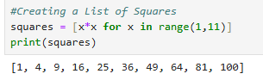

1. **Creating a list of Cubes**

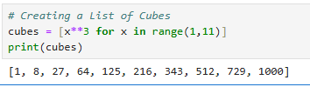

1. **Filtering Even Numbers**

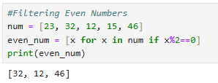

1. **Filtering Numbers Divisible by Three**

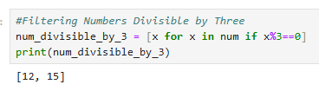

1. **Tag Numbers as ‘Even’ or ‘Odd’**

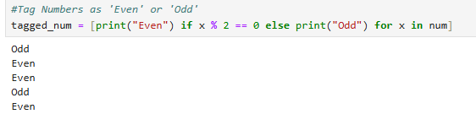

1. **Changing Negative Numbers to Zero**

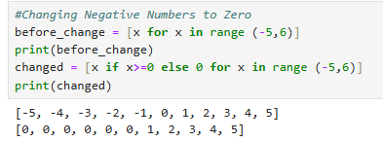

1. **Squaring Numbers Greater than Thirty**

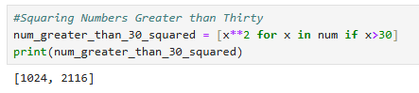

1. **Identifying Vowels from a Given String**

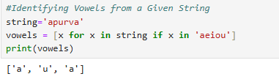

1. **Converting Temperature from Degree Celsius to Degree Fahrenheit**

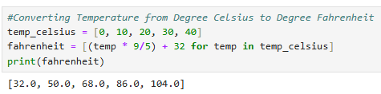

1. **Flattening a 2D List (Nested List Comprehension)**

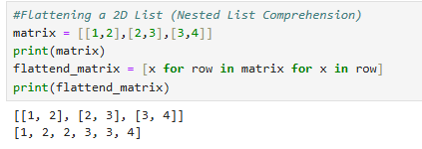

**2. Dictionary (Dict) Comprehension**

Dictionary comprehension is a concise and powerful technique in Python that allows developers to create dictionaries in a single line of code. Similar to list comprehensions, it enables clear, compact, and efficient dictionary generation without explicitly using multiple for loops. Dictionary comprehensions are a Pythonic way to build dictionaries quickly and elegantly. By balancing conciseness with clarity, developers can leverage this feature to write cleaner and more efficient code.

**Why is Dictionary Comprehension Needed?**

1. **Conciseness**: It allows creating dictionaries in a single, compact line rather than writing multiple lines of code with traditional loops.
2. **Readability**: The transformation logic is clear at a glance, making the code easier to understand and maintain.
3. **Efficiency**: Dictionary comprehensions execute faster in many cases compared to manually building dictionaries using loops.
4. **Combined Filtering and Mapping**: They enable building and transforming dictionaries while selectively including only the required items in one step.

**General Syntax:**



**Components:**

* **key_expression –** defines how keys are generated.
* **value_expression –** defines how values are generated.
* **iterable –** any sequence or object to iterate over (list, tuple, range, string, or dictionary).
* **item –** represents each element in the iterable.
* **if condition *(****optional****)* –** filters elements to include only those meeting specific criteria**.**

**Advantages of Dict Comprehension:**

* **Conciseness**: Reduces multiple lines of code into a single expression.
* **Readability**: Highlights transformation logic in a clear manner.
* **Efficiency**: Often faster than traditional for loops for creating dictionaries.

**Considerations while using Dict Comprehension:**

* For complex logic or deeply nested structures, traditional for loops can provide better readability.
* Performance implications may arise for extremely large datasets, though comprehensions are typically efficient for most cases.

**Example – Squares of Numbers from 1 to 10**

**Without using dict comprehension:**

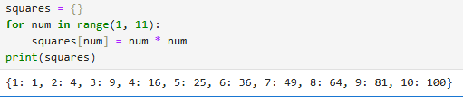

**Using dict comprehension:**

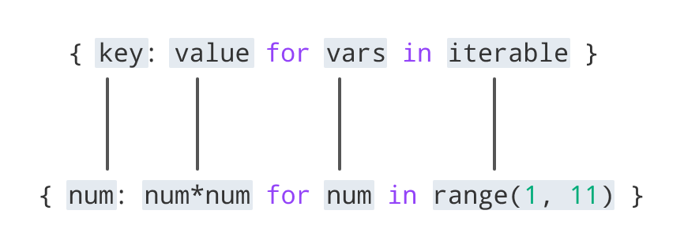

**Fig. 2: Example Showing Dict Comprehension**

**Step-by-step execution:**

1. Start with an empty dictionary {}.
2. Take the first number from range (1, 11) → num = 1.
   * Key → 1
   * Value → 1 * 1 = 1
   * Add {1: 1} to the dictionary.
3. Next number num = 2.
   * Key → 2
   * Value → 2 * 2 = 4
   * Add {2: 4} to the dictionary.
4. Repeat this until num = 10

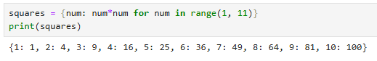

**Key Distinctions Between Dict Comprehension and Traditional Loop:**

**Table 2: Dict Comprehension vs Traditional Loop**

|  |  |  |
| --- | --- | --- |
| **Aspect** | **Without Dictionary Comprehension** | **With Dictionary Comprehension** |
| **Lines of Code** | Multiple lines (loop + assignment statements) | Single compact line |
| **Readability** | Step-by-step construction; shows how the dictionary is built | Directly shows what dictionary is being created |
| **Conciseness** | More verbose, less elegant | More compact and Pythonic |
| **Execution Speed** | Slightly slower due to repeated assignments | Often faster as it's optimized internally |
| **Filtering Capability** | Requires explicit if statements inside loop | Can integrate conditions inline (if inside comprehension) |
| **Preferred Use Case** | Good for complex or multi-step logic | Ideal for simple and clear transformations |

**Examples:**

1. **Squares of numbers 1-5**

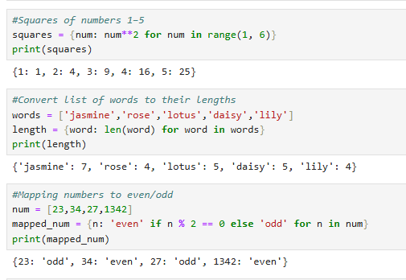

1. **Convert list of words to their lengths**



1. **Mapping numbers to even/odd**



1. **Creating a dictionary from two lists**

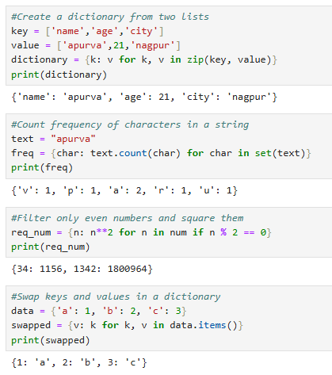

1. **Count frequency of characters in a string**



1. **Filter only even numbers and square them**



1. **Swap keys and values in a dictionary.**



1. **Create a dictionary of uppercase letters mapped to their ASCII codes (A–Z).**

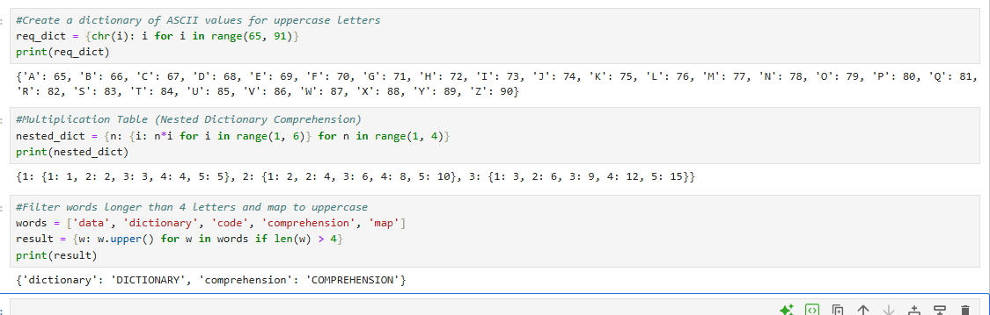

1. **Use nested dictionary comprehension to build a multiplication table for numbers 1–3 (with inner dictionary up to 5).**



1. **Filter words longer than 4 letters from a list and map them to uppercase.**



**3. File Handling**

File handling in Python enables programs to interact with files stored on a system for tasks such as creating, reading, writing, updating, and deleting files. It is essential for storing data persistently, processing large datasets, and performing real-world input/output operations efficiently. Proper file handling ensures data integrity and system resource management.

File handling is a vital feature in Python that allows for efficient interaction with the file system, enabling operations like reading, writing, and managing files securely. Using best practices such as the with statement and proper exception handling ensures resource safety and data integrity in real-world applications.

**Why Do We Need File Handling?**

* To store data permanently, even after the program ends.
* To access external files like .txt, .csv, .json, etc.
* To process large files efficiently without excessive memory use.
* To automate tasks like reading configurations or saving outputs.
* To handle input/output in real-world applications such as logs, reports, or user data.

**Opening a File in Python:**

Files are opened using the built-in open() function, which requires:

* **File name** (or path)
* **Mode** (operation type)

**Syntax –**



**Common Modes –**

**Table 3: Modes Used While Opening a File**

|  |  |
| --- | --- |
| **Mode** | **Description** |
| **r** | Read (default). File must exist. |
| **w** | Write. Overwrites file or creates new one. |
| **a** | Append. Adds content at the end of file. |
| **x** | Create. Fails if file already exists. |
| **b** | Binary mode (e.g., rb, wb). |
| **t** | Text mode (default, e.g., rt, wt). |

**Reading from a File:**

Python provides multiple methods to read file contents:

1. Read entire file –

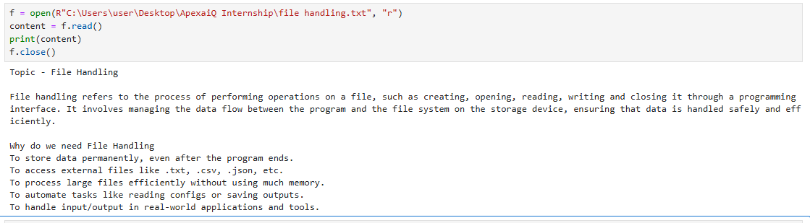

2. Read line-by-line –

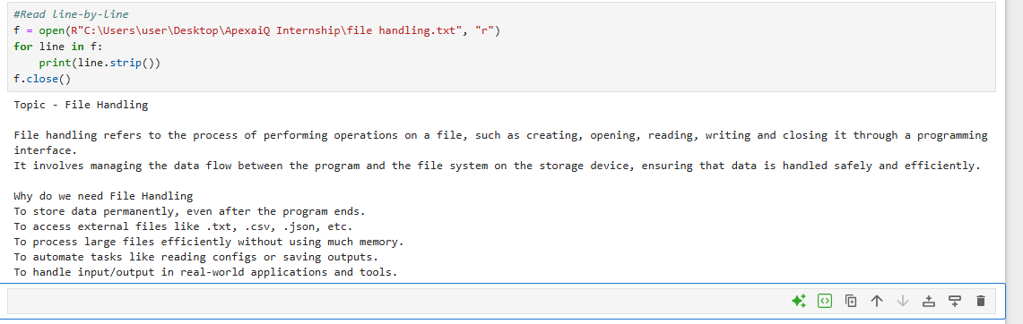

3. Read specific characters –

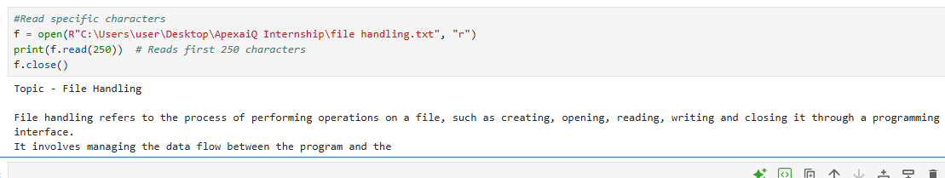

4. Read into a list –

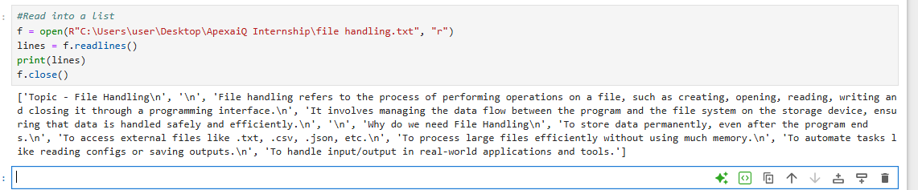

**Writing to a File:**

1. Write text

2. Append text

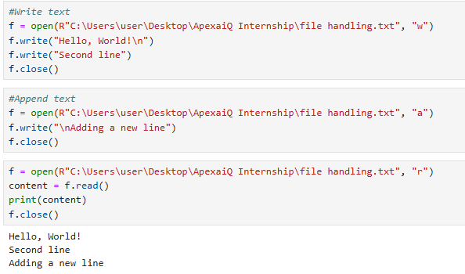

**Using with Statement (Best Practice):**

The with statement automatically handles file closing. It eliminates the need for f.close() and prevents resource leaks.

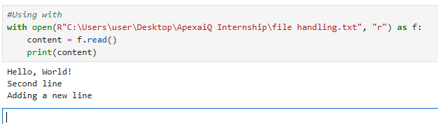

**Working with Binary Files:**

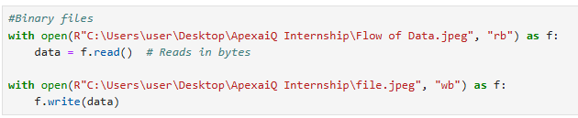

**Checking File Existence:**

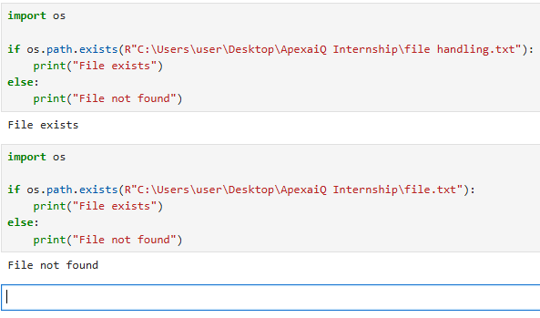

**Checking File Properties:**

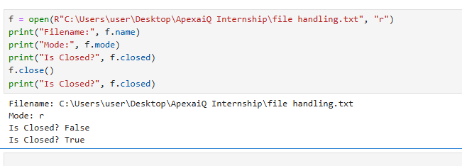

**Deleting a File:**

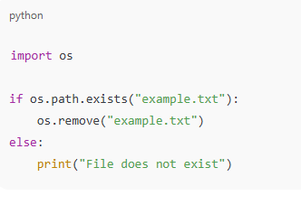

**4. Error Handling**

Error handling in Python is the process of detecting, managing, and responding to runtime errors without crashing the entire program. Instead of terminating abruptly when something goes wrong—like dividing by zero or opening a missing file—Python allows developers to handle these situations gracefully, improving program stability and user experience.

Error handling in Python ensures that unexpected issues do not cause program crashes and allows developers to build more reliable and user-friendly software. By using try–except blocks, along with else and finally clauses, developers can manage exceptions efficiently. Raising custom exceptions further improves clarity and control, while following best practices ensures programs remain maintainable and robust.

**Why Do We Need Error Handling?**

* Prevents abrupt program termination.
* Allows providing clear, user-friendly messages.
* Helps implement recovery steps (e.g., retrying or using defaults).
* Makes programs more robust and reliable.

**Common Types of Errors:**

1. **Syntax Errors** – issues in code structure detected before execution.
2. **Runtime Errors (Exceptions)** – occur during program execution:
   * ZeroDivisionError – divide by zero
   * FileNotFoundError – missing file
   * ValueError – invalid type conversion
   * IndexError – list index out of range
   * KeyError – dictionary key missing

**The try-except Block:**

The try–except block is the primary mechanism for error handling. The try block contains code that may raise an exception, while the except block catches and handles the error.

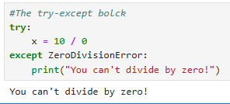

**Handling Multiple Exceptions:**

The errors can either be caught separately or by grouping them together.

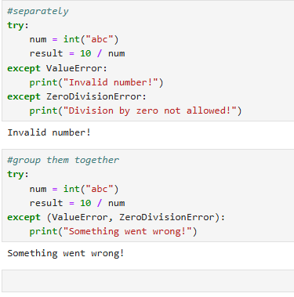

**Using else and finally:**

* **else block:** runs only if no exception occurs.
* **finally block:** always runs, whether or not an exception occurs (useful for cleanup).

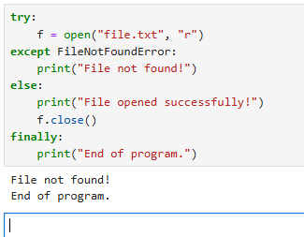

**Raising your own Exceptions:**

Use raise to signal errors intentionally.

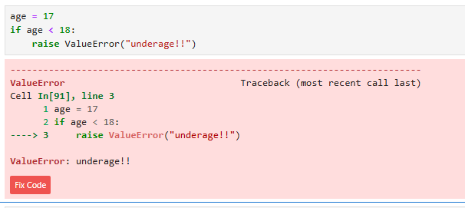

**Key Best Practices:**

* **Catch specific exceptions** rather than using a bare except.
* **Keep try blocks small** to isolate only risky code.
* **Use finally for cleanup** tasks (closing files, releasing resources).
* **Provide meaningful error messages** for easier debugging.

**5. Coding Standards**

Coding standards are a set of guidelines and best practices that define how code should be written, formatted, and organized. They ensure that code is consistent, readable, maintainable, and reliable across teams or projects. In essence, coding standards act as the etiquette of programming, preventing confusion and making software development more efficient.

Coding standards are not just about aesthetics — they are vital for building high-quality, secure, and maintainable software. By enforcing consistency in naming, formatting, commenting, and error handling, teams can minimize bugs, reduce development time, and improve collaboration. Adopting these standards ensures that code remains understandable, reliable, and scalable for future needs.

**Importance of Coding Standards:**

1. **Improved Readability:** Consistent formatting and naming conventions make code easier to understand.
2. **Enhanced Maintainability:** Clear and structured code simplifies debugging and feature modifications.
3. **Increased Collaboration:** Team members can work together seamlessly when everyone follows the same standards.
4. **Reduced Errors:** Consistent practices prevent common mistakes and improve overall code quality.
5. **Code Reuse:** A uniform code structure allows components to be easily reused across projects.
6. **Faster Development:** Standardized code helps developers quickly grasp logic and structure.
7. **Better Security:** Guidelines can include secure coding practices to reduce vulnerabilities.

**Key Aspects of Coding Standards:**

**1. Naming Conventions**

* Use meaningful names for variables, functions, and classes.
* Follow language-specific styles:
  + **Python:** snake_case for variables/functions, PascalCase for classes.
  + **Java, JavaScript, C#:** camelCase for variables/functions, PascalCase for classes.
* Avoid single-letter names except for simple loop counters.

**2. Code Formatting**

* Use consistent indentation (2 or 4 spaces; never mix tabs and spaces).
* Keep line length ≤ 80–100 characters.
* Follow a consistent brace/brace placement style.

**3. Commenting**

* Write comments to explain why, not just what, the code does.
* Keep comments updated as code changes.
* Avoid unnecessary or obvious comments.

**4. Code Structure**

* Break code into small, reusable functions.
* Avoid deeply nested loops or conditionals — use early returns or helper functions.
* Separate business logic, data handling, and presentation layers.

**5. Error Handling**

* Handle exceptions gracefully instead of letting programs crash.
* Provide meaningful error messages and proper logging.

**6. Testing and Validation**

* Follow test-driven development (TDD) where feasible.
* Ensure code passes linting tools and unit tests before merging.

**7. Version Control Practices**

* Use clear and concise commit messages.
* Keep commits small and focused on a single change.
* Follow branch naming conventions (e.g., feature/add-login, bugfix/fix-crash).

**Conclusion**

Mastering these core Python concepts—comprehensions for elegant data transformation, file handling for persistent storage, error handling for resilience, and coding standards for consistency—empowers developers to write high-quality software. Applying these techniques not only improves code readability and performance but also fosters scalability and collaboration in larger projects. By internalizing these practices, developers can produce programs that are efficient, maintainable, and aligned with professional software engineering principles.

Moreover, these skills reflect a deeper understanding of Python’s philosophy of simplicity and clarity. They prepare programmers to tackle real-world challenges, adapt quickly to evolving project requirements, and contribute meaningfully to team-based development. Whether building small scripts or enterprise-grade applications, these foundational practices ensure that the code remains robust, secure, and future-proof. Embracing them early creates a strong platform for learning advanced concepts and excelling as a professional developer.

***